**WEBD-1000**

*Coding Challenge 1 Tables*

Coding Challenges are to be completed and marked in class.

**Markup**

Create an HTML5 page that contains a table with 5 rows and 4 columns. The top row should use table headings. Fill the cells with content as you see fit.

One of the cells should include an image with a relevant link to that image.

Validation is not required for challenge completion.

**Styles**

Create an external CSS file with the following styles for the page created above:

* Change the table to be 800px wide
* The table should align to the middle of the page
* Add a border style to the table
* Create a style that will change the background color of every second row (zebra striping). Be sure to NOT include the heading row in this style.
* Create a style that will change the background color of every row, apart from the heading row, when the user hovers over with their mouse pointer

When complete, ask your instructor to check your work.

**WEBD-1000**

*Coding Challenge #4 Intro to Javascript*

Coding Challenges are to be completed and marked in class.

Make sure all code you create in challenges is properly nested, grouped and well-formed. Validation is not required for coding challenges. Coding Challenges are to be completed in class (meaning: you must attend in order to have the dropbox opened for you).

[Starting files for this challenge](https://www.google.com/url?q=https://drive.google.com/open?id%3D1-vhbhrtVTXCe55bBpKJS09XwTZvQn1oI&sa=D&ust=1573279423962000)

In cc4starter.html, note there is a <script> element that references a Javascript file called **average.js**. Functions have been created for you as follows:

**load()**

3 prompts have been created, asking the user for their full name, the number of hits they had last season, and the number of at-bats they had last season.

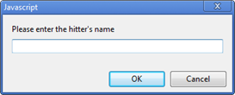

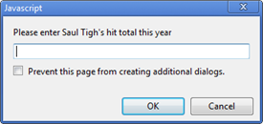

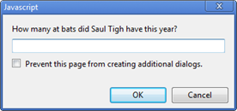

After you have these three pieces of data, they are **passed** to **battingAverage(**).

**battingAverage(*name, hits, abs*)**

Calculate the hitter’s batting average by dividing the number of hits by the number of at-bats. For example:

var average = hits/abs;

Then format the average so that it only displays 3 decimal places. To do this, use the toFixed method, which can be used in this syntax:

//This is just pseudo-code, use proper variable names

let num = number.toFixed(x) //Where “x” is the number of decimal places you need

After this, determine if the average is less than .300. If so, display this message within an **<h2>** inside the “results” section element:



If the average is greater than or equal to .300, display this message, again within an **<h2>**:

